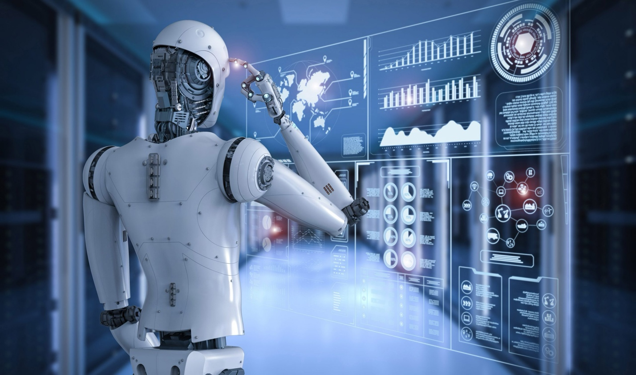

[This Photo](https://tekhdecoded.com/robots-and-ai-are-they-todays-new-service-workers/) by Unknown Author is licensed under [CC BY-SA-NC](https://creativecommons.org/licenses/by-nc-sa/3.0/)

**The Impact of AI on Jobs: An In-Depth Analysis**

**Introduction**

Artificial Intelligence (AI) is rapidly transforming the landscape of the modern workforce. With advancements in machine learning, automation, and data processing, AI is increasingly becoming integral to various job roles across industries. This essay explores the impact of AI on jobs using data analysis, highlighting the most and least affected roles, domain-specific insights, the relationship between tasks and AI models, and implications for job security. The findings provide a comprehensive understanding of how AI is reshaping the workforce, offering insights into the challenges and opportunities presented by this technological evolution.

**Overview of AI Impact on Job Roles**

The data reveals a wide range of AI influence across different job roles. Some jobs, particularly in data-intensive fields such as IT and administrative roles, exhibit high levels of AI integration, while others, such as traditional or hands-on positions, show much lower impact. Roles like Communications Manager, Data Entry, and Data Collector are among the most affected, with AI impact scores reaching as high as 98%. These jobs are characterized by repetitive or data-driven tasks that are easily automatable, leading to increased AI integration and reduced human involvement.

On the other hand, jobs such as Technician, Lead Pastor, and Deaconess have minimal AI impact, with scores around 5%. These roles often involve complex human interactions, creativity, or physical tasks that are less susceptible to automation by current AI technologies. This contrast highlights the varying degrees to which AI affects different job types, emphasizing the need for nuanced approaches to workforce planning and adaptation.

**Domain-Specific Insights: Most and Least Affected Industries**

The analysis further reveals that the impact of AI varies significantly across industries. The **Data & IT** and **Administrative & Clerical** domains are the most affected, as these fields involve repetitive tasks, data processing, and roles that are easily augmented or replaced by AI models. For example, data entry tasks, which require minimal cognitive effort, are prime candidates for automation, allowing organizations to reduce costs and increase efficiency.

Conversely, domains such as **Medical & Healthcare**, **Supply Chain & Logistics**, and **Hospitality** are among the least affected by AI. While AI is used in these sectors, it typically serves to support rather than replace human work, such as assisting in decision-making, enhancing diagnostic precision, or streamlining logistical processes. This highlights that while AI is pervasive, its role can vary significantly—from augmentation in high-skill sectors to outright replacement in more routine tasks.

**Task and AI Model Analysis**

A closer examination of the data shows a moderate correlation between the number of tasks and the number of AI models used, suggesting that jobs with more tasks tend to utilize more AI models. However, this relationship does not directly translate to a higher AI impact score, indicating that the nature of the tasks and how AI is applied are crucial factors. For instance, a job with numerous complex tasks may require multiple specialized AI models, yet still depend heavily on human oversight.

Efficiency metrics, such as tasks completed per AI model, further reveal that some roles use AI more effectively than others. Jobs with a higher tasks-per-model ratio tend to be more reliant on AI for task completion, highlighting potential vulnerabilities to future automation. This underscores the importance of understanding not just how much AI is used, but how effectively it is integrated into workflows.

**AI Workload Ratio and Job Security**

The **AI Workload Ratio** metric is a critical indicator of job security, with roles exhibiting high ratios being more at risk of full automation. These jobs rely heavily on AI to complete their tasks, making them vulnerable to technological advancements that could replace human labor altogether. The data suggests that jobs with high AI impact and workload ratios are often found in rapidly evolving industries, such as tech and communications, where the drive for efficiency and innovation fuels AI adoption.

This dynamic presents both risks and opportunities. On one hand, there is a clear risk of job displacement as AI capabilities continue to improve. On the other hand, there are significant opportunities for workers to transition into new roles that involve managing, overseeing, or enhancing AI systems. The evolving job market will increasingly value skills that complement AI rather than compete with it.

**The Future of AI in the Workforce**

The data indicates a clear trend towards increasing AI adoption, particularly in roles that involve data processing, communication, and repetitive tasks. As AI models become more sophisticated, even traditionally creative and strategic roles are beginning to see significant AI impact. For example, AI is now used in content creation, marketing strategy, and customer service, where it augments human decision-making and enhances productivity.

For jobs heavily affected by AI, there is a critical need for reskilling workers to adapt to AI-driven environments. Training programs that focus on complex tasks that AI cannot easily perform—such as strategic decision-making, empathy-driven customer service, and creative problem-solving—will be essential. Moreover, new job roles are emerging in AI management, oversight, and enhancement, providing avenues for workers to shift from roles at risk of automation to those that involve working alongside AI.

**Recommendations**

To navigate the growing influence of AI in the workplace, several recommendations emerge from this analysis:

1. **For Organizations**: Invest in reskilling and upskilling programs for employees in high-risk roles. Explore how AI can augment human workers rather than replace them, maintaining job security while enhancing productivity.
2. **For Employees**: Focus on developing skills that are complementary to AI, such as strategic thinking, creativity, and complex problem-solving. These skills are less likely to be replicated by AI, positioning individuals for success in an AI-augmented workforce.
3. **For Policy Makers**: Consider policies that support workforce transitions, including education and training initiatives, to ensure that workers can adapt to the evolving job market influenced by AI technologies. Supporting innovation while protecting the workforce will be key to a balanced approach.

**Conclusion**

The impact of AI on jobs is profound and multifaceted, affecting industries, job roles, and the nature of work itself. While AI offers significant benefits in terms of efficiency and productivity, it also poses challenges, particularly for jobs that are highly automatable. The future workforce will require a careful balance of technological advancement and human skill development, emphasizing roles that involve complex decision-making, creativity, and oversight of AI systems. By embracing these changes proactively, society can harness the benefits of AI while mitigating its risks, ensuring a future where technology and humanity work in tandem for mutual advancement.